**A Group Project Report on**

**AUTOMATED ATTENDANCE MARKING SYSTEM USING FACE DETECTION AND RECOGNITION**

**Submitted to partial fulfillment of the academic requirements of**

**Jawaharlal Nehru Technological University Hyderabad**

**For the award of the degree of**

**Bachelor of Technology**

**in**

**Computer Science and Engineering**

**(2018 – 2022)**

**Submitted By**

**D. SAKETH REDDY G. NITISH KUMAR M. VARUN SAI**

**18311A0509 18311A0519 18311A0532**

**Under the esteemed Guidance of**

**Mrs. TALAKOTI MAMATHA**

**Internal Guide**

**Assistant Professor, Department of CSE**

**and**

**Mr. DEVAVARAPU SREENIVASARAO**

**Project Coordinator**

**Assistant Professor, Department of CSE**



**DEPARTMENT OF COMPUTER SCIENCE AND ENGINEERING**

**SREENIDHI INSTITUTE OF SCIENCE AND TECHNOLOGY**

***(Autonomous)***

**Yamnampet, Ghatkesar Mandal, Medchal District, Hyderabad - 501301**

**Submission Date: August 2021**

**Batch No: A-18-GP-15**



**CERTIFICATE**

This is to certify that this Group Project report on “**AUTOMATED ATTENDANCE MARKING SYSTEM USING FACE DETECTION AND RECOGNITION**”, submitted by D. SAKTETH REDDY(18311A0509), GUNDAPU NITISH KUMAR (18311A0519) and M. VARUN SAI(18311A0532) in the year 2021 in partial fulfillment of the academic requirements of Jawaharlal Nehru Technological University for the award of the degree of Bachelor of Technology in Computer Science and Engineering, is a bonafide work that has been carried out by them as part of their **Group Project** during **Third Year Second Semester** ,under our guidance. This report has not been submitted to any other institute or university for the award of any degree.

**Mrs. Talakoti Mamatha**

**Assistant Professor**

**Department of CSE**

**Internal Guide**

**Mr. Devavarapu Sreenivasarao Dr. Aruna Varanasi**

**Assistant Professor Professor**

**Department of CSE HOD-CSE**

**Group Project Coordinator**

**External Examiner**

**Date:**

**DECLARATION**

We, **DAIDA SAKETH REDDY (18311A0509), GUNDAPU NITISH KUMAR (18311A0519)** and **M. VARUN SAI (18311A0532)**, students of **SREENIDHI INSTITUTE OF SCIENCE AND TECHNOLOGY, YAMNAMPET, GHATKESAR,** studying IIIrd year IInd semester, **COMPUTER SCIENCE AND ENGINEERING** solemnly declare that the Group Project work, titled **“AUTOMATED ATTENDANCE MARKING SYSTEM USING FACE DETECTION AND RECOGNITION”** is submitted to **SREENIDHI INSTITUTE OF SCIENCE AND TECHNOLOGY** for partial fulfillment for the award of degree of Bachelor of technology in **COMPUTER SCIENCE AND ENGINEERING**.

It is declared to the best of our knowledge that the work reported does not form part of any dissertation submitted to any other University or Institute for award of any degree.

**ACKNOWLEDGEMENT**

We would like to express my gratitude to all the people behind the screen who helped me to transform an idea into a real application.

We would like to express our heart-felt gratitude to our parents without whom we would not have been privileged to achieve and fulfill our dreams. We are grateful to our principal, **Dr. T. Ch. Siva Reddy,** who most ably runs the institution and has had the major hand in enabling us to do this project.

We profoundly thank **Dr**. **Aruna Varanasi**, Head of the Department of Computer Science & Engineering who has been an excellent guide and also a great source of inspiration to our work.

We would like to thank our internal guide **Mrs. Talakoti Mamatha** for her technical guidance, constant encouragement and support in carrying out our project at college.

We also extend our gratitude to our project coordinator **Mr. Devavarapu Sreenivasarao**, who lent us valuable guidance and led us towards the staged completion of the project.

The satisfaction and euphoria that accompany the successful completion of the task would be great but incomplete without the mention of the people who made it possible with their constant guidance and encouragement crowns all the efforts with success. In this context, I would like thank all the other staff members, both teaching and non-teaching, who have extended their timely help and eased my task.

**DAIDA SAKETH REDDY 18311A0509**

**GUNDAPU NITISH KUMAR 18311A0519**

**M. VARUN SAI 18311A0532**

**AUTOMATED ATTENDANCE MARKING SYSTEM USING FACE DETECTION AND RECOGNTION**

**Abstract**

Today, the world is getting digitalized and we can observe the installation of many electronic devices surrounding us. Until recently the attendance in a class room is taken by calling the roll calls, but now a days, the system of scanning the bar codes embedded in the ID Cards for the attendance is adopted inorder to increase efficiency. but the method is being discarded due to fraudulent activities and internal errors in the embedded system like if the bar codes does not work properly. With the rapid development of artificial intelligence in recent years, facial recognition gains more and more attention. hence by using the concept of facial recognition, we are proposing a model of image based facial recognition system for attendance marking. In the proposed model, if we are able to obtain the images of the students present in the classroom using cctv cameras, we can get the facial features of the students present in the class and use it for marking attendance by using image processing and machine learning methods. Currently this method of adopting image based facial recognition system for attendance is in its early stage of development and there are only few successful models for its implementation.

**List of Figures**

|  |  |  |  |
| --- | --- | --- | --- |
| **S.No.** | **Figure No.** | **Figure Title** | **Page No.** |
| **1** | **3.1** | System Architecture | **5** |
| **2** | **3.3.1** | Class Diagram | **7** |
| **3** | **3.3.2** | Activity Diagram | **7** |
| **4** | **3.3.3** | Usecase Diagram | **8** |
| **5** | **3.3.4** | Sequence Diagram | **8** |
| **6** | **5.1** | Login Page – 1 | **28** |
| **7** | **5.2** | Login Page – 2 | **29** |
| **8** | **5.3** | Student Page – After authentication | **30** |
| **9** | **5.4** | Student Page – Upload Images | **30** |
| **10** | **5.5** | Student Page – Student Details | **31** |
| **11** | **5.6** | Student Page – View Attendance | **31** |
| **12** | **5.7** | Admin Page – After credentials | **32** |
| **13** | **5.8** | Admin Page – Upload Image | **33** |
| **14** | **5.9** | Admin Page – Student Details | **33** |
| **15** | **5.10** | Admin Page – Images | **34** |
| **16** | **5.11** | Admin Page – Help desk | **34** |
| **17** | **5.12** | Admin Page – Get Faces | **35** |
| **18** | **5.13** | Admin Page – Create Dataset | **35** |
| **19** | **5.14** | Admin Page – Create Student | **36** |

**INDEX**

**Abstract** i

**List of Figures** ii

|  |  |  |
| --- | --- | --- |
| **S. No** | **Content** | **Page No.** |
| **1** | **INTRODUCTION** | **1 - 2** |
|  | * 1. **Scope**   2. **Existing System**   3. **Proposed System** | **1**  **1**  **2** |
| **2** | **SYSTEM ANALYSIS** | **3 - 4** |
|  | **2.1. Functional Requirement Specifications**  **2.2. Performance Requirements**  **2.3. Software Requirements**  **2.4. Hardware Requirements** | **3**  **4**  **4**  **4** |
| **3** | **SYSTEM DESIGN** | **5 - 10** |
|  | **3.1. Architecture Design**  **3.2. Modules**  **3.3. UML Diagrams**  **3.3.1. Class Diagrams**  **3.3.2. Activity Diagram**  **3.3.3. Use Case Diagram**  **3.3.4. Sequence Diagram** | **5**  **6**  **7**  **7**  **7**  **8**  **8** |
| **4** | **SYSTEM IMPLEMENTATION** | **9 - 27** |
| **5** | **OUTPUT SCREENS** | **28 - 36** |
| **6** | **CONCLUSION AND FUTURE SCOPE** | **37** |
| **7** | **REFERENCES** | **38** |
| **8** | **PO CORRELATION** | **39** |

**CHAPTER – I**

**INTRODUCTION**

**INTRODUCTION**

Automated attendance marking system is a new age innovation which leverages the ml algorithms and the algorithms of computer vision for marking the attendance of a person. It can be used as a replacement to the currently used systems like manual marking of attendance and card based biometric scanning.

The face recognition system is one of the biometric informatics systems which is used to get the facial features of the person. Unlike different types of the recognition systems, face recognition system is unique and different because it uses both computer vision and related algorithms for the analysis of the facial features. In the proposed model, the facial features of the respective person is extracted by using RESNETS (residual neural networks) and the analysis and the classification is done using KNN algorithm.

This model reduces the efforts of the humans and also assures accuracy in terms of prediction and also it is very less prone to errors. Several malpractices and be eliminated using this. All the data related to attendance will be stored centrally so, only authorized people can access it.

* 1. **Scope**

At present this model is built using the tkinter of python along with several ml algorithms so, it is simply a UI based system deployed in a computer and all the attendance related information is handled in a host computer. But this can be scaled to very high level like this model can be embedded inside a cc camera which will have the entire view of the class and when this type of embedding is done it becomes easier to mark the attendance because the moment when a student enters the class his face will be recognized automatically by the deployed cc camera and attendance can be marked easily. This further reduces the effort in marking the attendance.

* 1. **Existing System**

The existing system uses conventional methods such as:

**1.** Traditional attendance marking system by calling roll calls**.**

**2.** Marking the attendance by scanning the barcodes embedded inside the ID cards of the systems.

**3.** Marking the attendance by using the concept of image processing and facial recognition.

**The drawbacks of this system are:**

* There is a high chance of proximity in case of marking the attendance by roll calls
* Bar coded cards very prone to fraudulent activities and internal errors in the embedded system like malfunctioning of barcodes causes errors.
* The method of using image processing is completely based on the computer vision and the prediction and the accuracy of the model created is not up to the mark.
  1. **Proposed System**

The Proposed model makes use of both image processing methods and machine learning techniques to accurately predict and classify the facial features present in the photo.

The current system that we are proposing is the modification of the existing facial recognition systems. Our system uses the computer vision concepts to extract the facial features and uses the concept of machine learning techniques to classify them. It can also be used for extracting the biometric information present in the face as the facial encodings will differ for each and every person.

In Future, we are trying to develop to a video and audio-based recognition system which can further increase the accuracy and gives wide options for prediction of the person, which can improve the current attendance marking system.

**SYSTEM ANALYSIS**

In this section we look to describe in detail the requirements we seek from our project in order to be efficient. This description is divided into 4 parts, Functional Requirement Specification, Performance Requirements, Software Requirements, and Hardware Requirements. In Functional Requirement Specification we identify different modules of our system and express the role performed by each module. In Performance Requirements, we broadly outline the requirements in terms of performance from the system. In Software and Hardware Requirements we label the minimum requirements needed for running the project.

**2.1 Functional Requirement Specification**

Our system can be divided into the following modules:

1. **User Interface:**

It acts as the base of the whole project and it acts as the intermediate between the model, database and the user. This is designed in tkinter in python. It is also used to authenticate the user for security.

1. **Face Recognition model:**

This accepts the image and extracts the image encodings from it and predicts the class of the image using the face encodings. It is the combination of RESENT Model and the KNN model.

1. **Database Manager:**

It is used to store the information of the students. We can access this information using UI and we can update the information accordingly.

**2.2 Performance Requirements**

This section entails the rudimentary prerequisites for our system to be perfectly functional. We define a set of requirements for our system and make sure our system lives up to those requirements. The predefined requirements are as follows:

* The system must make accurate predictions.
* The system must be fast and responsive to the user’s interaction.
* Above all preprocessing of data plays a major role in determining the performance of the system so, this must be done very effectively.

**2.3 Software Requirements**:

* **Operating System**: Microsoft Windows XP or higher, any Linux based OS.
* **Languages**: Python 3.5 and later versions

**2.4 Hardware Requirements**:

Processor : Intel i3 6th Gen or higher

Hard Disk : 128 GB.

RAM : 4 GB or higher

**SYSTEM DESIGN**

In this section we look to demonstrate the design of our system from various perspectives. First, we will explore the architecture of the system, then we will look at the modules involved in our system, and finally, we will look at the UML diagrams designed for implementing our system. Each perspective will be examined comprehensively.

**3.1 Architectural Design**

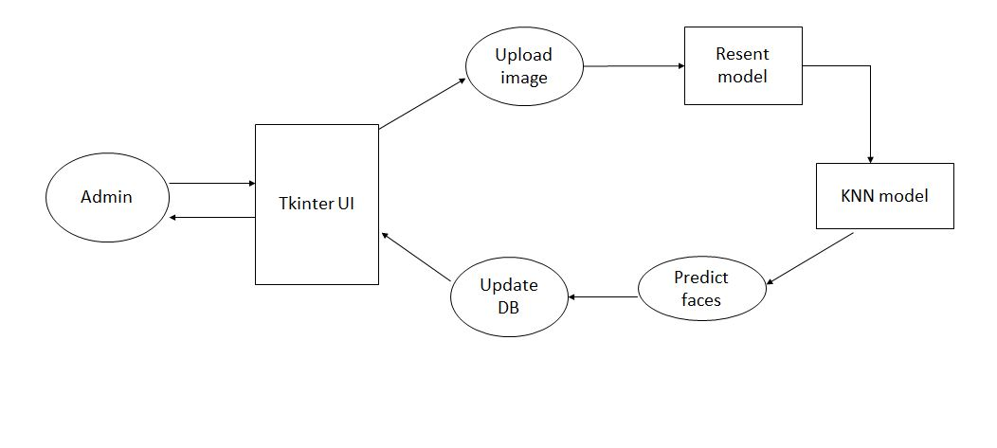

**Fig 3.1**: Architectural Design

To simply analyze the above diagram, we can chiefly break down our system into the frontend, the backend (Database manager) and the ML model in the middle. The frontend is built using tkinter of python. The backend is about the database connectivity with project and updates related to the attendance are made and the ML model which is at the center and the heart of the entire project is used for recognition of the person.

**3.2 Modules**

1. **Open CV:**

Open CV stands for open-source computer vision it is a library which contains all the algorithms for Image processing.

1. **Pillow library:**

Once we are able to obtain the data i.e., images of the students it will be stored inside our secondary memory now we need to load the images into our project this can be done using pillow library.

**3. Residual neural networks:**

When an image is loaded into the project it is actually in the form of a 3-dimensional data it must be reduced in order to improve the performance of our model so only necessary data is extracted from the image this necessary data is called as face encodings. So, all the necessary encodings can be extracted from the images using RESNET. Here encodings refer to facial features of the person like eyes, nose, ears, mouth etc.,

**4. KNN model:**

Once the necessary encodings are extracted all these encodings together makes the dataset and this dataset is used to train our model. Once the model is trained it can be used to make the predictions.

**5. MySQL-connector-python**:

It is the necessary module inorder to establish the connection between the code and the database.

**6. NumPy:**

Necessary for the mathematical computation involved in the code.

**3.3 UML Diagrams**

The UML diagrams we used for the development of our system are as given below:

**3.3.1 Class Diagram:**

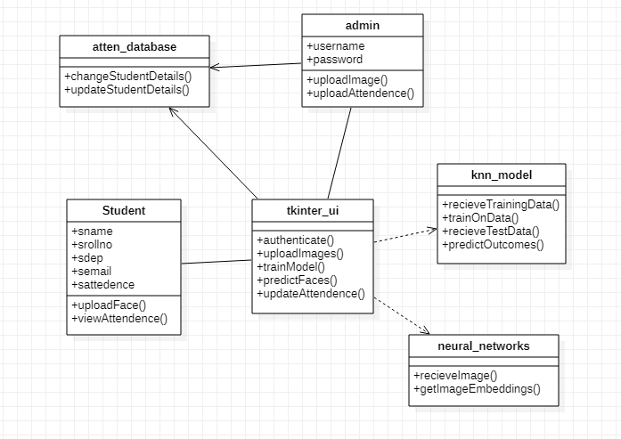

**3.3.2 Activity Diagram:**

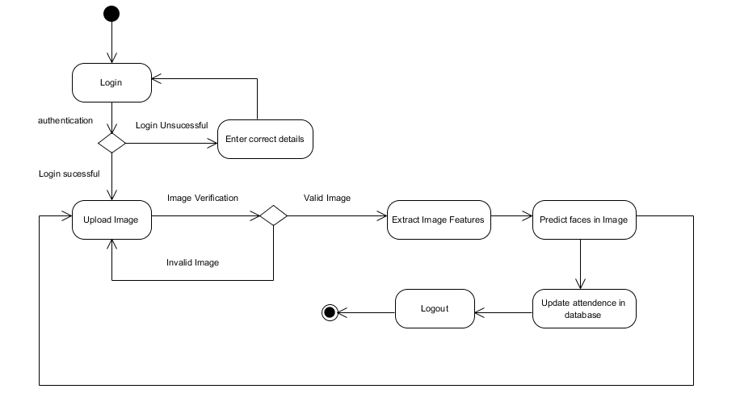

**3.3.3 Usecase Diagram:**

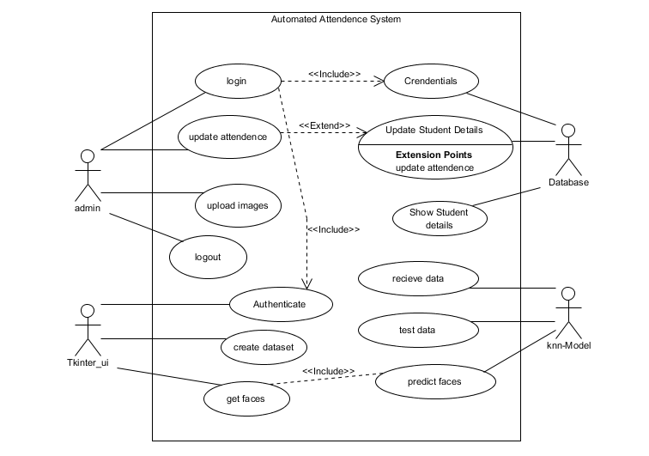

**3.3.4 Sequence Diagram:**

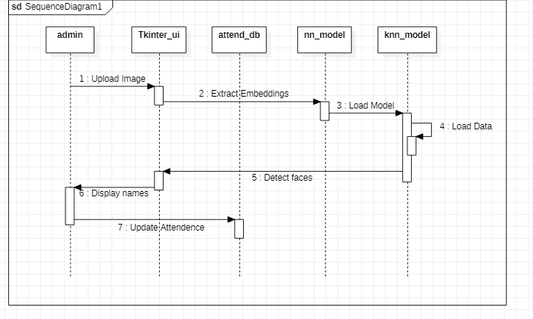

**SYSTEM IMPLEMENTATION**

**4.1 Code**

**Createdata.py**

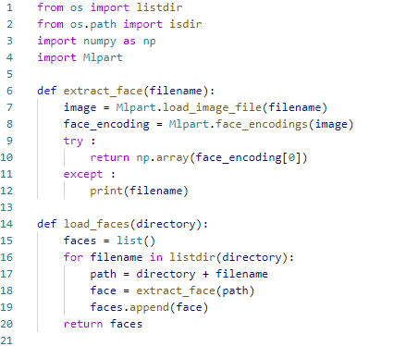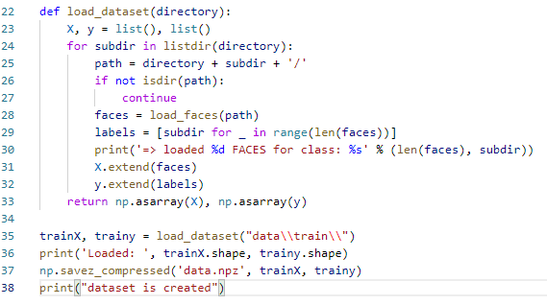

**MLpart.py**

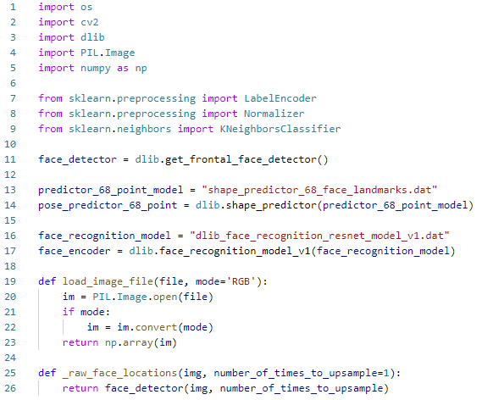

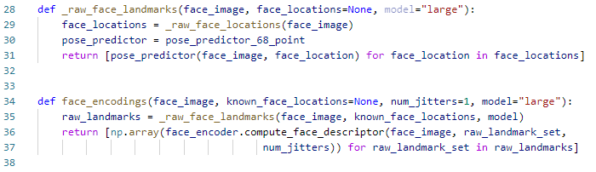

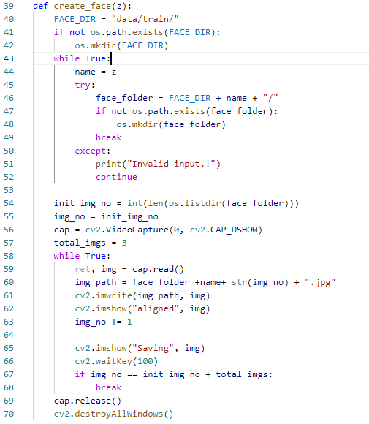

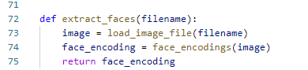

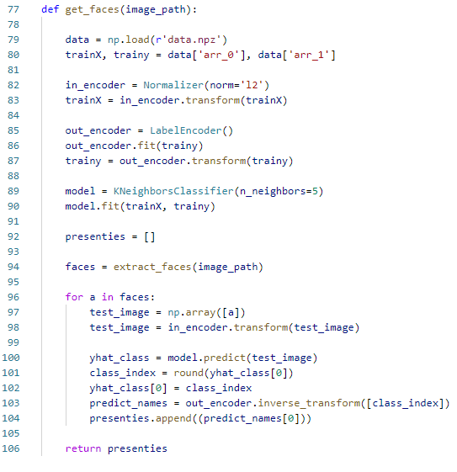

**Main.py**

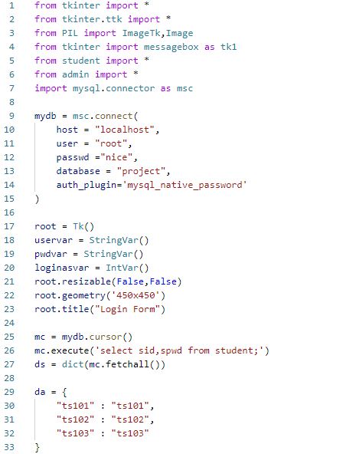

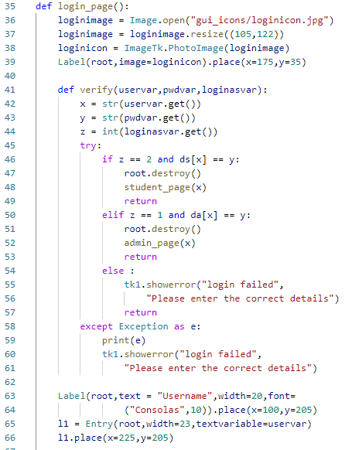

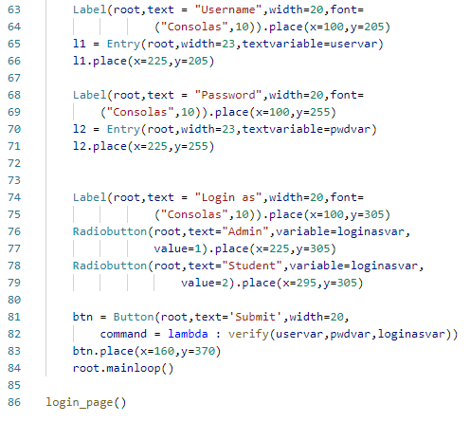

**Student_page.py**

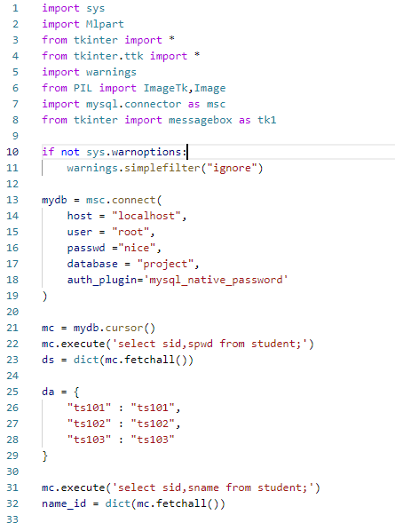

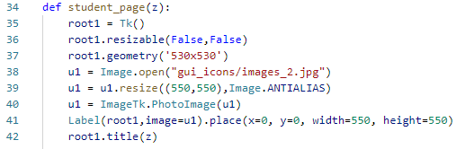

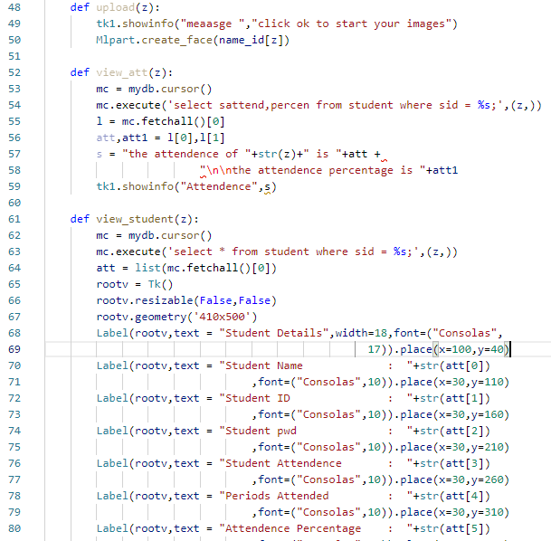

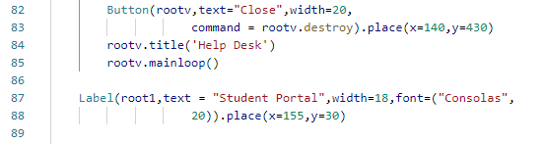

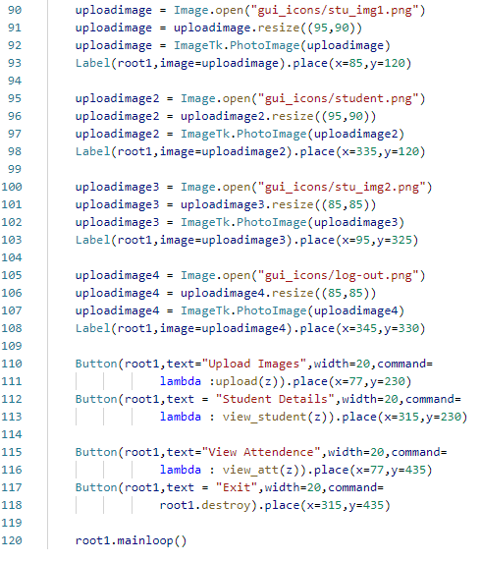

**Admin_page.py**



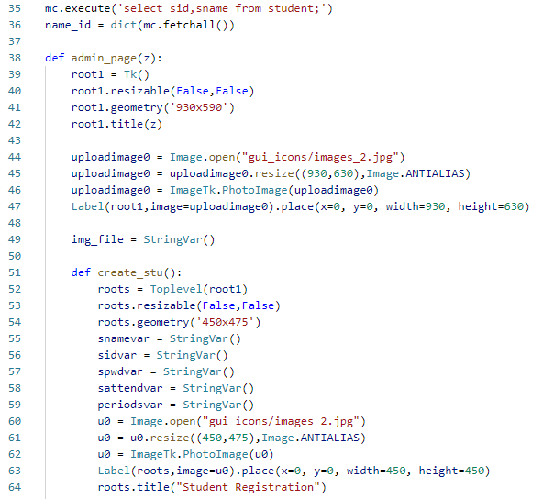

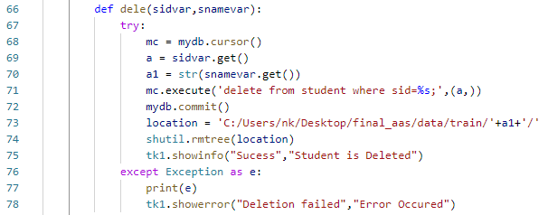

\

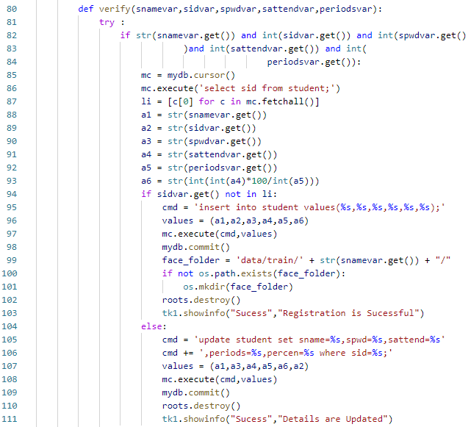

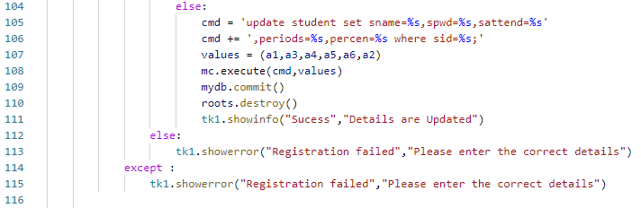

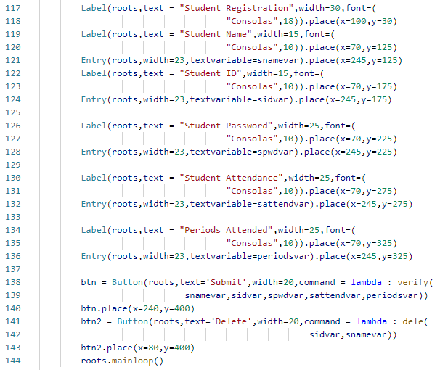

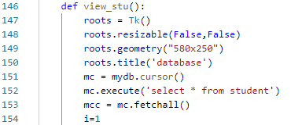

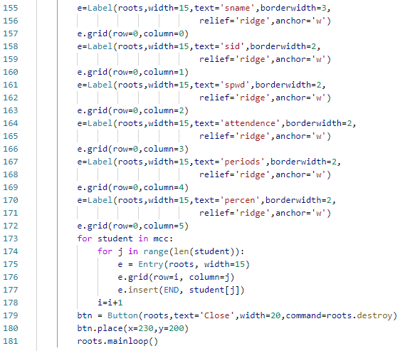

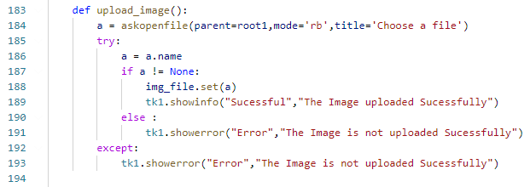

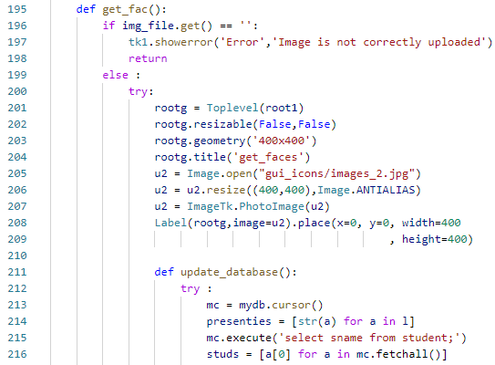

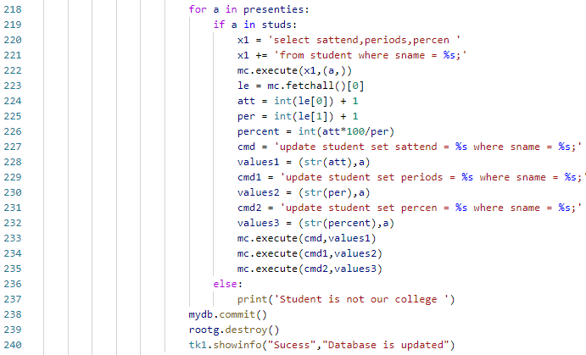

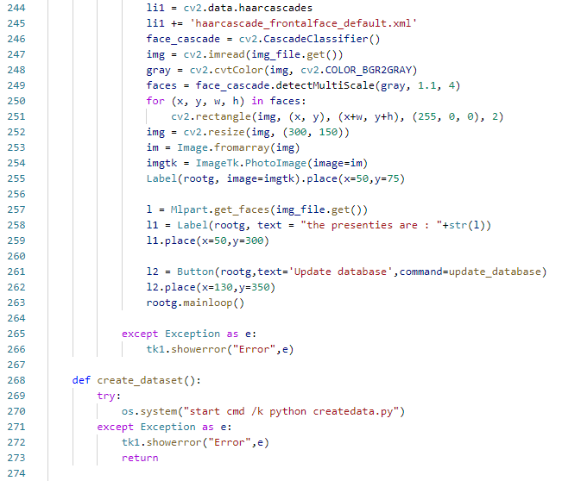

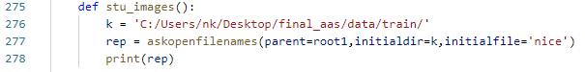

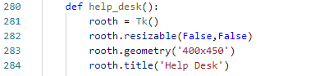

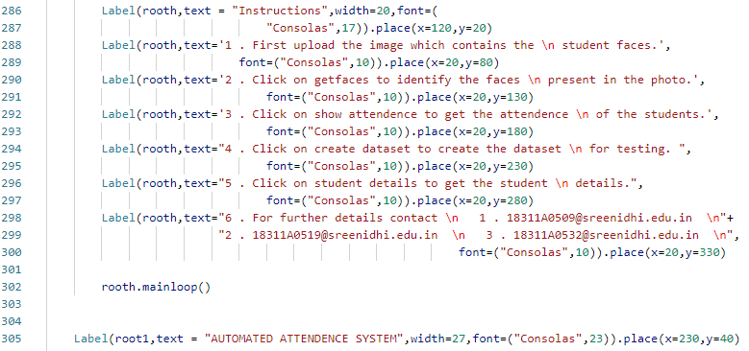

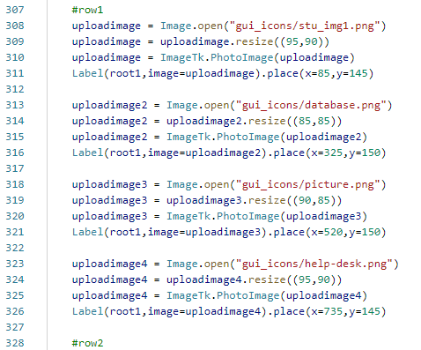

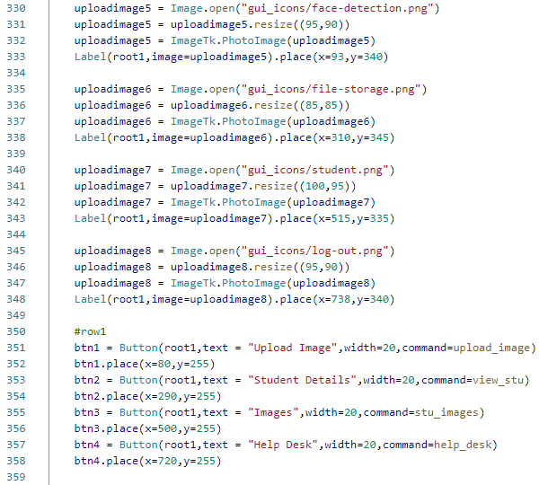

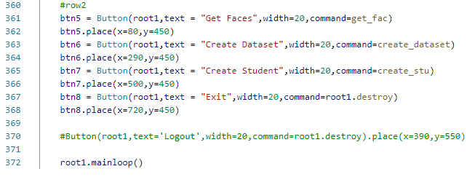

**OUTPUT SCREENS**

In this section we shall look at the output screens of various functionalities provided by our project along with the descriptions of each functionality.

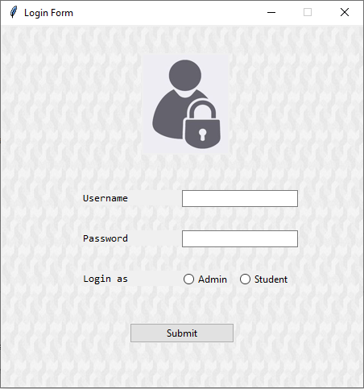

**Fig 5.1: Login Page - 1**

The Login page is the first thing the admin or the student can see as they run our project. It comes with authentication and two options to login as admin and student. If the credentials are correct then the admin or the student will able to login and select their choices and can makes changes, else we will see an error message as shown below.

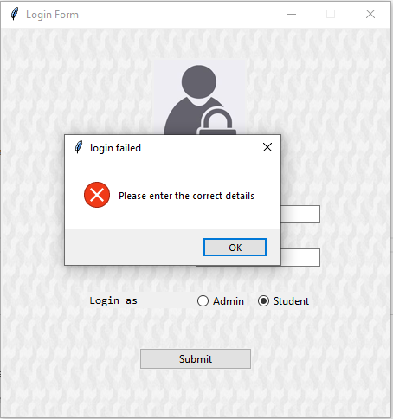

**Fig 5.2: Login Page - 2**

**STUDENT PAGE:**

If the credentials are correct for the student, the student page will open which have the following functionalities.

* Upload Images – will upload the images of the student using front camera.
* Student details – will show the details of the student who is currently using.
* View Attendance – will show the attended periods and the attendance percentage of the student.
* Logout – will able to exit the Application.

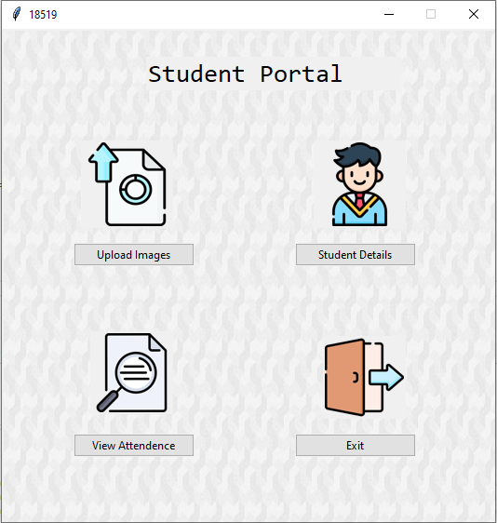

**Fig 5.3: Student Page – After Authentication**

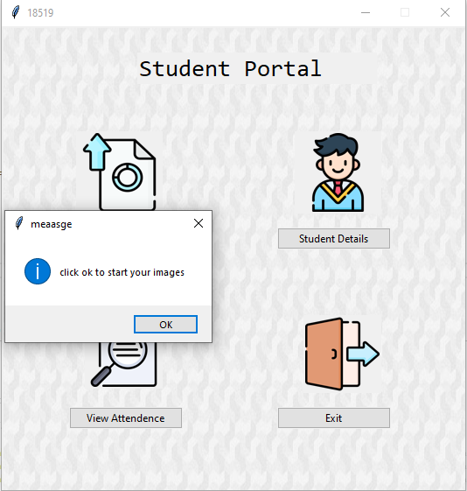

**Fig 5.4: Student Page – Upload Images**

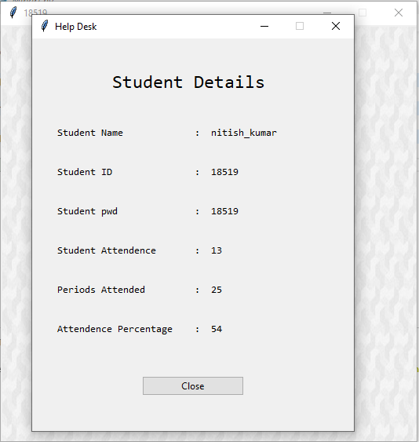

**Fig 5.5: Student Page - Student Details**

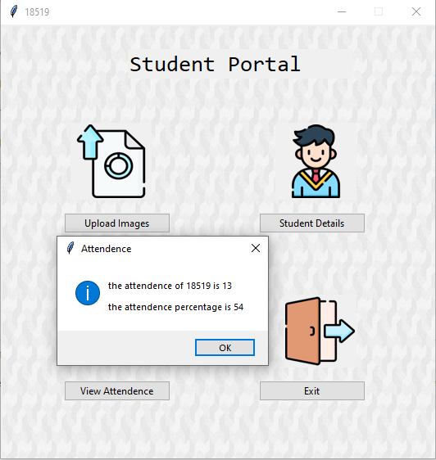

**Fig 5.6: Student Page – View Attendance**

**ADMIN PAGE:**

If the credentials are correct for the student, the student page will open which have the following functionalities.

* Upload Image – the admin has to upload the images of the student which have the faces of the students present in class.
* Student details – will show the details of the students present in the database.
* Images – will show the images of the students which are used for training.
* Helpdesk – will show how to use the application.
* Get Faces – will show the faces of the students present in the image.
* Create Dataset – will create a dataset necessary for training the Model.
* Create Student – will authorize the admin to create a student.
* Logout – will able to exit the Application.

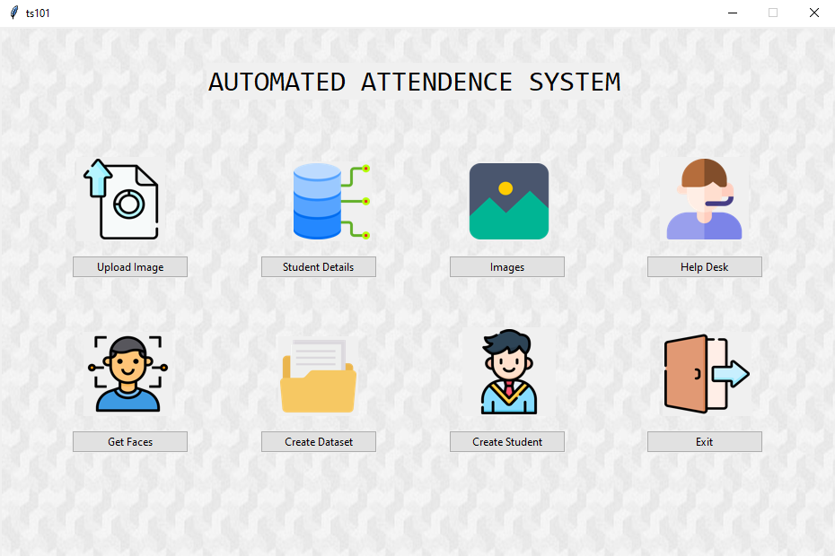

**Fig 5.7: Admin Page – After Credentials**

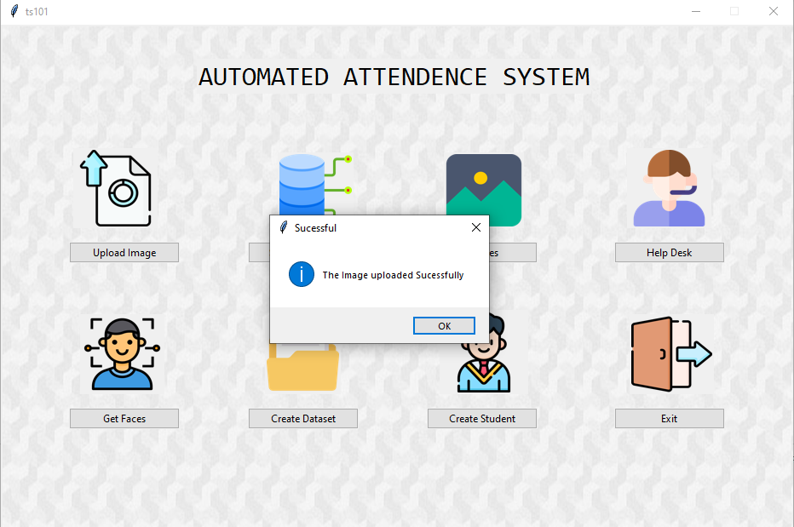

**Fig 5.8: Admin Page – Upload Image**

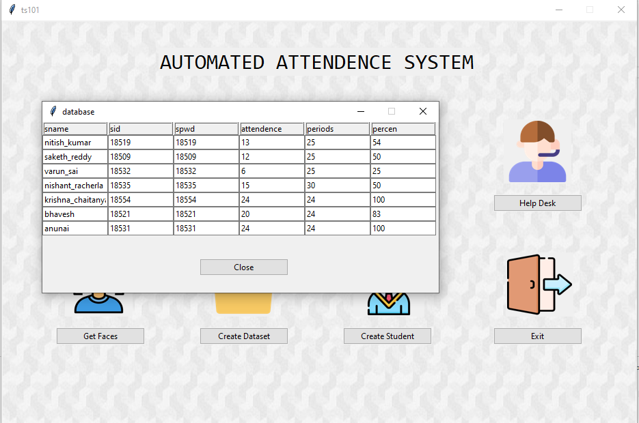

**Fig 5.9: Admin Page – Student Details**

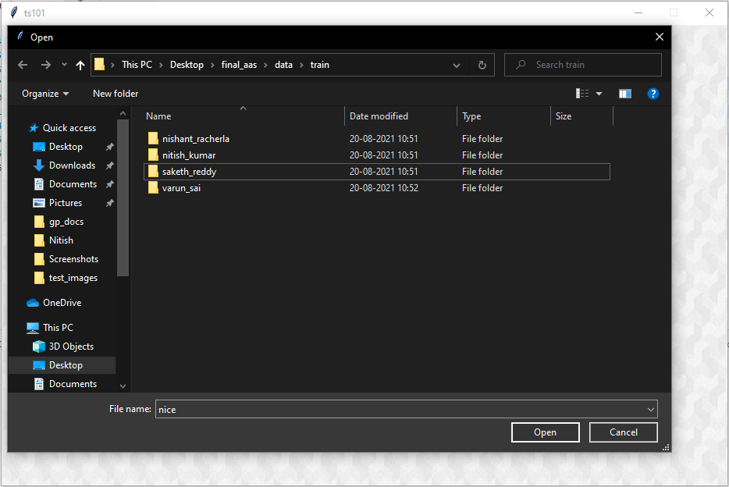

**Fig 5.10: Admin Page – Images**

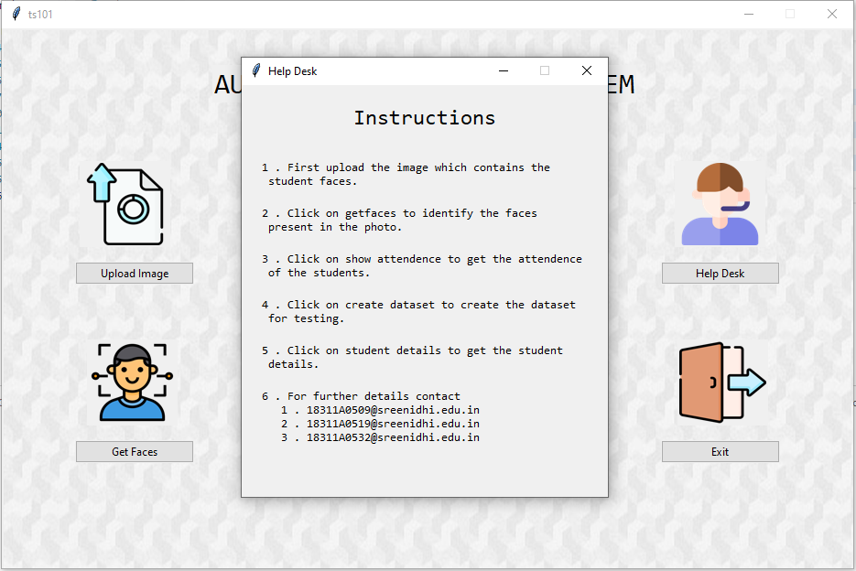

**Fig 5.10: Admin Page – Help Desk**

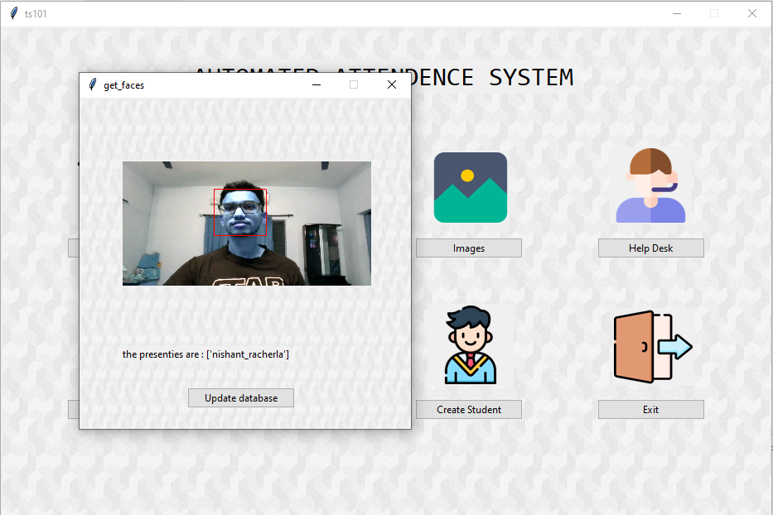

**Fig 5.11: Admin Page – Get Faces**

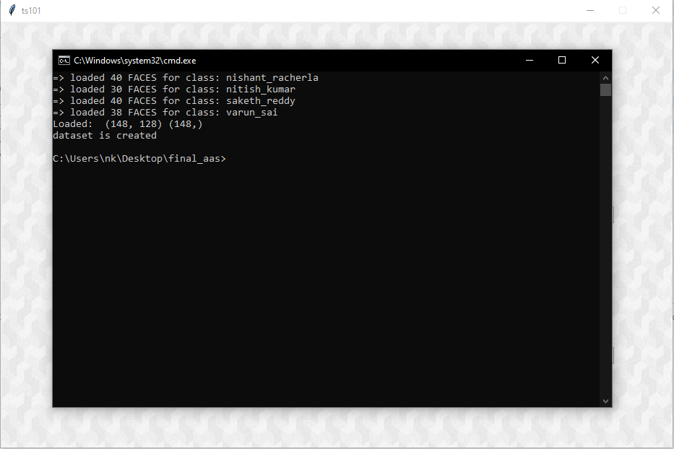

**Fig 5.12: Admin Page – Create dataset**

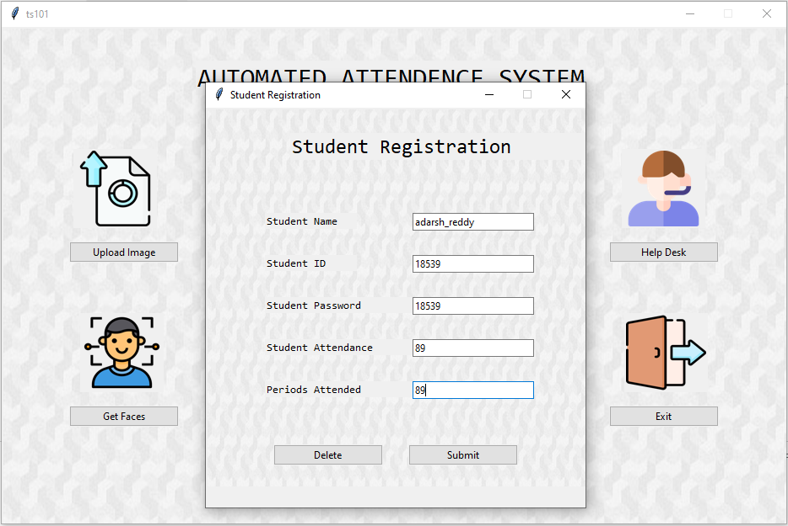

**Fig 5.13: Admin Page – Student Registration**

This concludes the output screens of our project.

**CONCLUSION & FUTURE SCOPE**

The current system that we are proposing is the modification of the existing facial recognition systems. Our system uses the computer vision concepts to extract the facial features and uses the concept of machine learning techniques to classify them. It can also be used for extracting the biometric information present in the face as the facial encodings will differ for each and every person.

In our project we used RESNET model for the extraction of the image embeddings and KNN algorithm for the classification of the images. The model that we have developed gives us more than 95% accuracy.

In Future, we are trying to develop to a video and audio-based recognition system which can further increase the accuracy and gives wide options for prediction of the person, which can improve the current attendance marking system.

**REFERENCES**

* <https://d2l.ai/chapter_convolutional-modern/resnet.html>
* <https://scikitlearn.org/stable/modules/generated/sklearn.neighbors.KNeighborsClassifier.html>
* <https://docs.python.org/3/library/tkinter.html>
* [Deep Coupled ResNet for Low-Resolution Face Recognition | IEEE Journals & Magazine | IEEE Xplore](https://ieeexplore.ieee.org/abstract/document/8303213?casa_token=zZOEu7cOvHgAAAAA:jDg8XjJAJq5fdl5_uYM4upbIxBLWGkyJ54_JEmPnncl1i0vceDfbiaOjkc0UlJ_BliNoIVcYE3U)
* [MySQL :: MySQL Connector/Python Developer Guide :: 5.1 Connecting to MySQL Using Connector/Python](https://dev.mysql.com/doc/connector-python/en/connector-python-example-connecting.html)
* [GitHub - davisking/dlib-models: Trained model files for dlib example programs.](https://github.com/davisking/dlib-models)
* <http://dlib.net/face_detector.py.html>

|  |  |  |  |
| --- | --- | --- | --- |
| **Team No: A-18-GP-15** | | **Title** | **Guide Name** |
| **Roll No** | **Name** |
| 18311A0509 | D. SAKETH REDDY | **AUTOMATED ATTENDENCE MARKING SYSTEM USING FACE DETECTION AND RECOGNITION.** | Mrs. T. MAMATHA  Assistant  Professor |
| 18311A0519 | G. NITISH KUMAR |
| 18311A0532 | M. VARUN SAI |

**ABSTRACT**

Today, the world is getting digitalized and we can observe the installation of many electronic devices surrounding us. Until recently the attendance in a class room is taken by calling the roll calls, but now a days, the system of scanning the bar codes embedded in the ID Cards for the attendance is adopted inorder to increase efficiency. but the method is being discarded due to fraudulent activities and internal errors in the embedded system like if the bar codes does not work properly. With the rapid development of artificial intelligence in recent years, facial recognition gains more and more attention. hence by using the concept of facial recognition, we are proposing a model of image based facial recognition system for attendance marking. In the proposed model, if we are able to obtain the images of the students present in the classroom using cctv cameras, we can get the facial features of the students present in the class and use it for marking attendance by using image processing and machine learning methods. Currently this method of adopting image based facial recognition system for attendance is in its early stage of development and there are only few successful models for its implementation.

**Student 1 Guide HOD**

**Student 2**

**Student 3**

|  |  |  |  |
| --- | --- | --- | --- |
| **Team No: A-18-GP-15** | | **Title** | **Guide Name** |
| **Roll No** | **Name** |
| 18311A0509 | D. SAKETH REDDY | **AUTOMATED ATTENDENCE MARKING SYSTEM USING FACE DETECTION AND RECOGNITION.** | Mrs. T. MAMATHA  Assistant  Professor |
| 18311A0519 | G. NITISH KUMAR |
| 18311A0532 | M. VARUN SAI |

|  |  |  |  |  |  |  |
| --- | --- | --- | --- | --- | --- | --- |
| **Batch No.** | **Roll No.** | **Product/app** | **Ethics** | **research** | **social science** | **safety** |
|
| **A-18-GP-15** | 18311A0509 | **✓**App |  |  | **✓**(M) |  |
| 18311A0519 |
| 18311A0532 |

|  |  |  |  |  |  |  |  |  |  |  |  |
| --- | --- | --- | --- | --- | --- | --- | --- | --- | --- | --- | --- |
| **SREENIDHI INSTITUTE OF SCIENCE AND TECHNOLOGY**  snist autonomous logo  **DEPARTMENT OF COMPUTER SCIENCE AND ENGINEERING**  **Projects Correlation with POs** | | | | | | | | | | | |
| **PO1** | **PO2** | **PO3** | **PO4** | **PO5** | **PO6** | **PO7** | **PO8** | **PO9** | **PO10** | **PO11** | **PO12** |
| **H** | **H** | **M** | **H** | **H** | **M** | **L** | **H** | **H** | **H** | **M** | **M** |

|  |  |
| --- | --- |
| **H** | **High** |
| **M** | **Moderate** |
| **L** | **Low** |

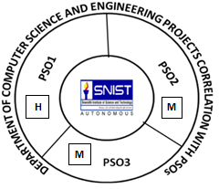

**Guide HOD**

Mrs. Talakoti Mamatha